***CONVERTING INVOICE ITEM to DEPOSIT***

Once all ***Invoice Items*** are entered and reconciled with Invoice user can convert them to deposits. Only Invoice Items that involve purchase of materials listed in the system can be converted (user can only create invoice item for materials).

To covert Invoice Item to deposit user

1. Clicks on the button next to Invoice Item:

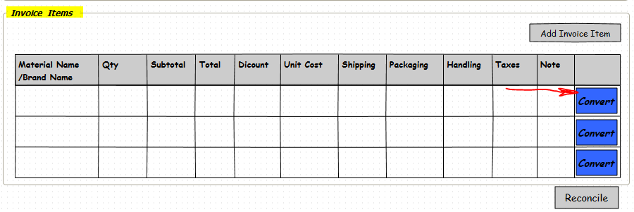

1. When user attempts to “Converts” Invoice Item to Deposit before the action takes place system performs series of checks:
2. System makes sure that there is no record in the Deposit table that has same invoice number and Material Id. If such record is found, system emits Message: “Deposit for this item has been previously created. Please, confirm with warehouse manager“
3. If no such combination of Invoice Item and Material ID is found system opens “New Deposit Form”

This form is different from form for manually created deposit: values in highlighted fields are copied from “Invoice” and “Invoice Item” read only.

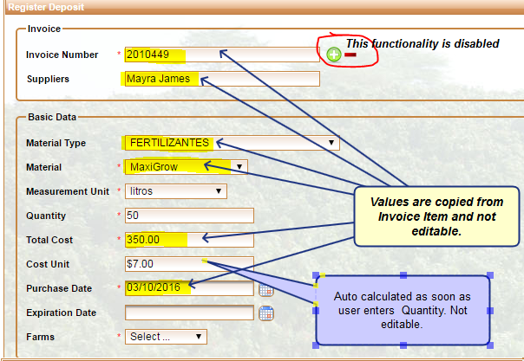

* Invoice Number, Supplier, Material Type, Material, Total Cost, Purchase Date are copied from related Invoice and Invoice Item. User should not be able edit this fields.
* User has to populate: Measurement Units, Total Quantity (in units selected), and Expiration date if applied.
* AS soon as Quantity is entered, system calculates Unit Cost. This value should not be editable by the user.
* User should not be able to change Invoice Number. Functionality that selects Invoices from Invoice table is disabled.

***Making sure no double entry is created:***  When Deposit is manually ( by entering information from Register Deposit Form under Deposits Tab), system should also check that combination for ***Invoice Number*** and ***Material Id*** is unique.